**How to Properly Wash**

**and Maintain Curly or Kinky Hair**

**By Lorenzo Wyman May 31, 2025**

**Table of Contents**

* **How to Properly Wash and Maintain Curly or Kinky Hair** … **pg. 1**
* Table of Contents ………………………………………………………. pg. 1
* Introduction and Overview ………………………………………… pg. 2
* Things to be Aware Of ………………………………………………… pg. 2
* **Washing Your Curly or Kinky Hair** ………………………………………. **pg. 2 - 6**
* Steps …………………………………………………………………………… pg. 3
* Applying Oils & Cream ………………………………………………… pg. 7
* **Conclusion** ……………………………………………………………………………. **pg. 7**

**Introduction and Overview**

There comes a time when everyone wants to experience change, whether it's emotionally or physically. But the bottom line of your reason for change is to bring forth new opportunities to express yourself! The same thing applies to hair, especially curly and kinky textures (type 3a to 4c).

Our hair is one of the features on our bodies that people pay close attention to. This is why it’s important to treat your hair good by washing and maintaining it. This could be by yourself or at a salon, but it’s important to watch out for some cosmetologists and stylists at some salons. So, we’re going to learn how to wash our hair ourselves.

**Things to be Aware Of**

As I mentioned earlier, there are a plethora of hairstylists that are so eager to “perfect” their crafts and in the process:

* Simply **play** in a lot of customers’ hair, further **damaging it** in the process.
* Stylists who wear faces that are green with envy because your or other customers' hair may belonger, healthier, nicer in density, or have a nicer color than their own.
* Becoming **“scissor happy”** and trimming more than you may have asked, or adding additional chemicals to your hair so that by the time your next wash comes around, your hair is in a way **worse** condition than it once was.

**Washing Your Curly or Kinky Hair**

**What You’ll Need:**

* Detangling brush (UnBrush brush highly recommended!),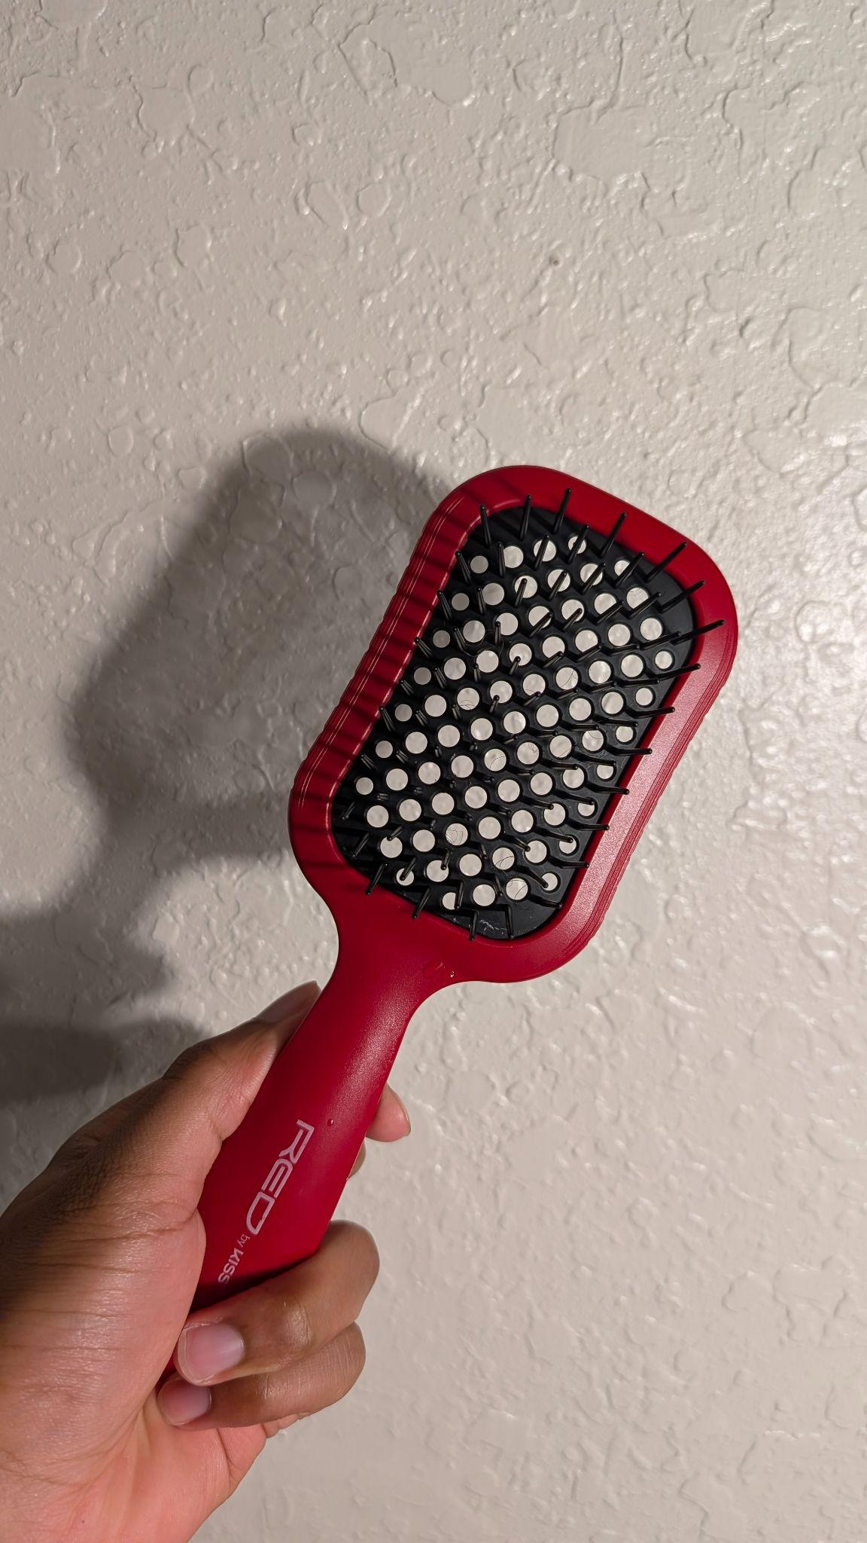
* Shampoo(s) of choice,
* Conditioner(s) of choice,
* Deep Conditioner(s) of choice,
* A place to wash your hair (sink, shower),
* Blow dryer or towel.

**Steps:**

1. **Detangle** - similar to combing; from ENDS to ROOTS of scalp to prevent tangles in the shower, save time, and have less breakage (if you prefer to do so in the shower, **skip to step 4**).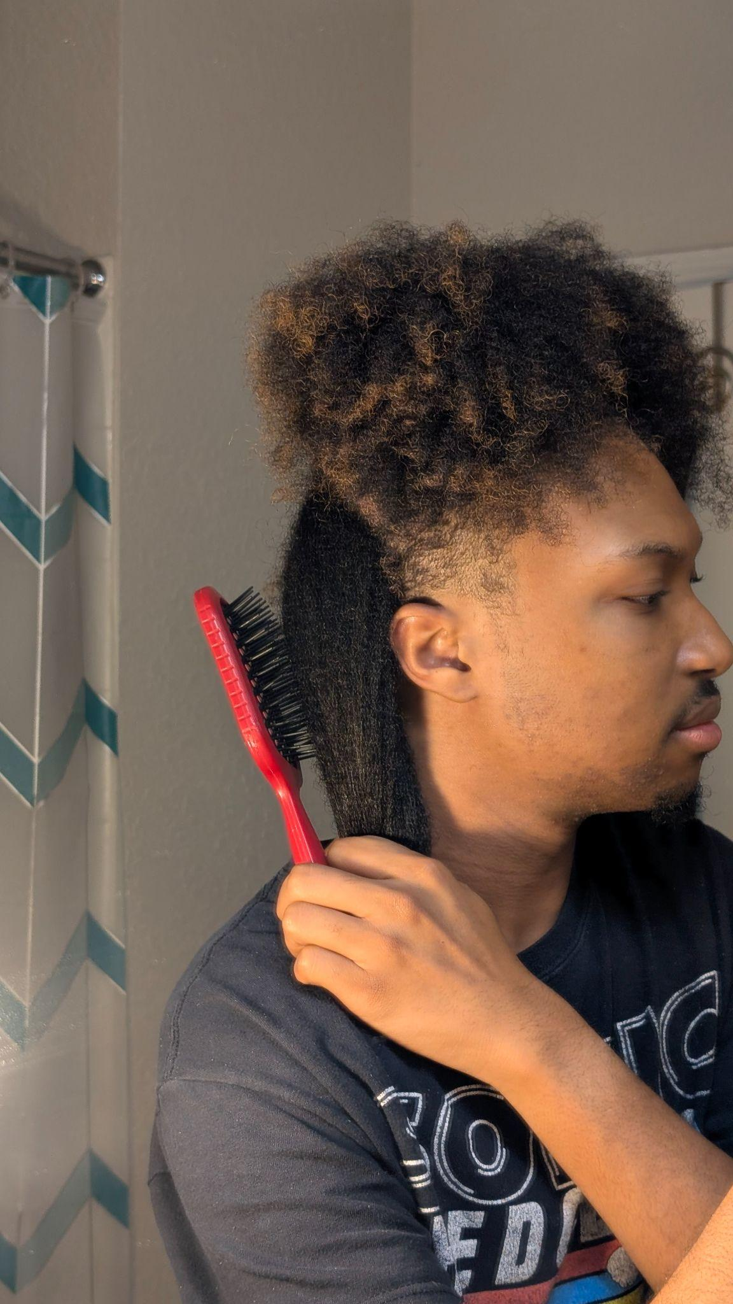
2. **Sectioning** (Optional) - Divide typically into sections of 2 to 6, depending on preference, to focus on individual sections of hair at a time.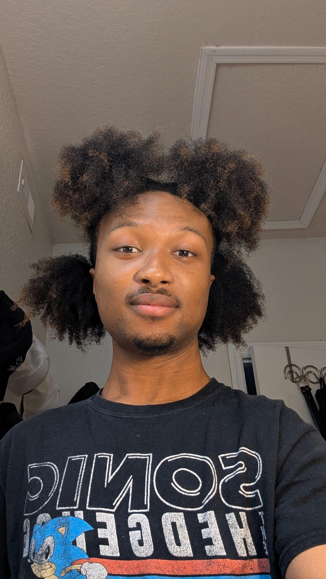

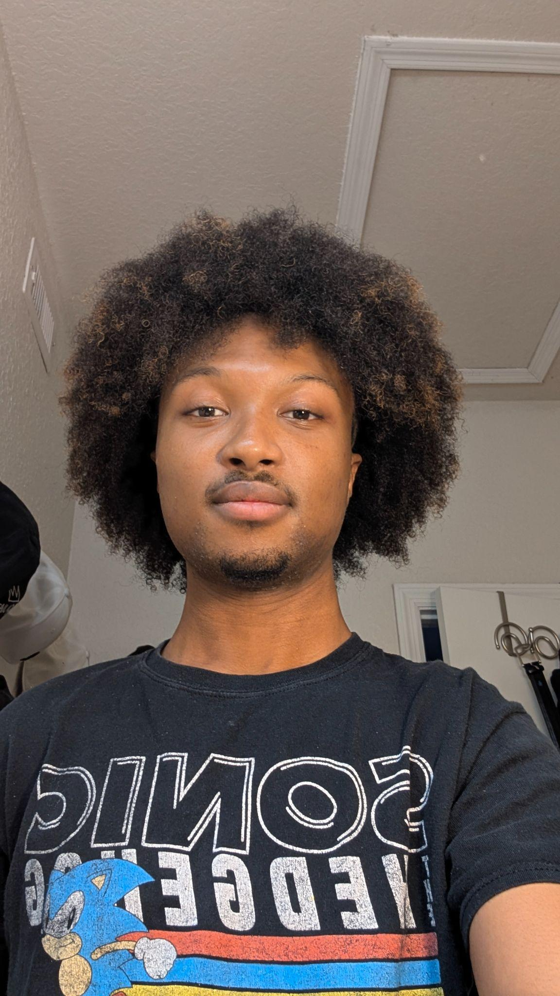

1. **Pre-Shampoo (Pre-Poo as often referred)** - Put a small amount of shampoo into a spray bottle and spray into your hair while detangling (ifyou choose to detangle while outside of the shower).

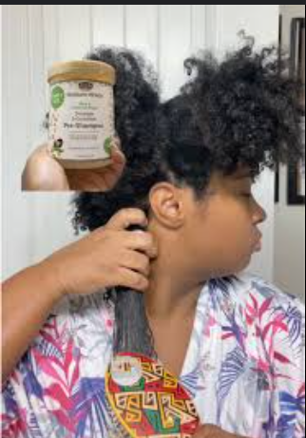

**Figure 8:** African Pride Pre-Shampoo from curlsbyroshell on TikTok

**Source:** [curlsbyroshell on TikTok](https://www.tiktok.com/@curlsbyroshell/video/7487255226114706718)

1. **Make sure the water is warm** - Allow the water to reach a temperature not too hot to avoid **heat damage** or burns, allowing the hair follicles to open up.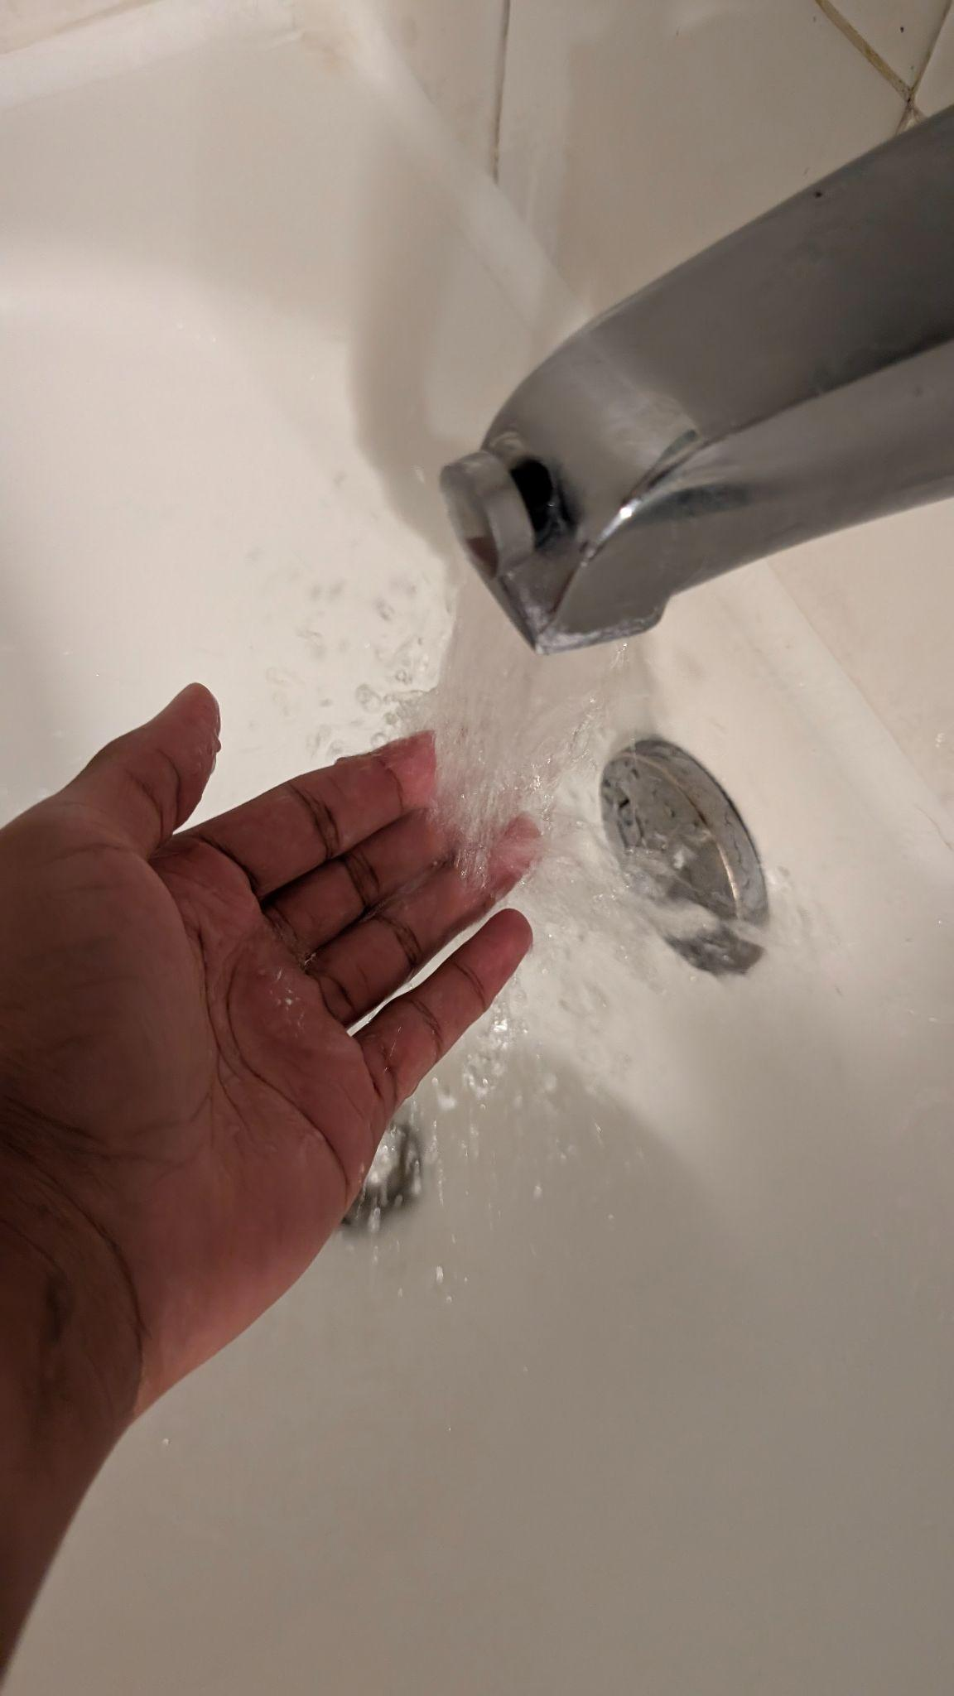
2. **\*Optional Route** - If you choose to detangle in the shower, starting with the back sections, detangle from ends to roots with that section in the water. Then, continue to the shampoo step.
3. **Shampooing** - Depending on how many sections, in our first back section, use a reasonably sized amount of shampoo and start working it in from ends to roots. Making sure to get into the scalp aswell.



**Figure 9:** Shampooing Curly Hair the Right Way

**Source:** [Medium](https://medium.com/@curladvice1/how-to-shampoo-curly-hair-the-right-way-in-8-steps-3a-to-4c-hair-washing-tips-7adba62abf3)

1. **Rinse Step(s)** - Rinse out the shampoo **thoroughly** after repeating step 6 for each section.
2. **Conditioning** - After shampooing all of our sections, move on to conditioning. You can choose to turn the water temperature up a bit to create more steam so that the moisture sets in before rinsing out the conditioner. After 3-5 minutes, rinse.
3. **\*Optional Step: Deep Conditioning** - If you just had a protective style (braids, locs, etc) and you want to regain intensive moisture in your hair, then use your deep conditioner and allow 3 to 30 minutes to let the deep conditioner sit in your hair before rinsing.
4. **\*Optional Step: Leave-In Conditioner** - At this point, when you're outside (or inside the shower), style your hair completely normally as you would if you were using any other products.

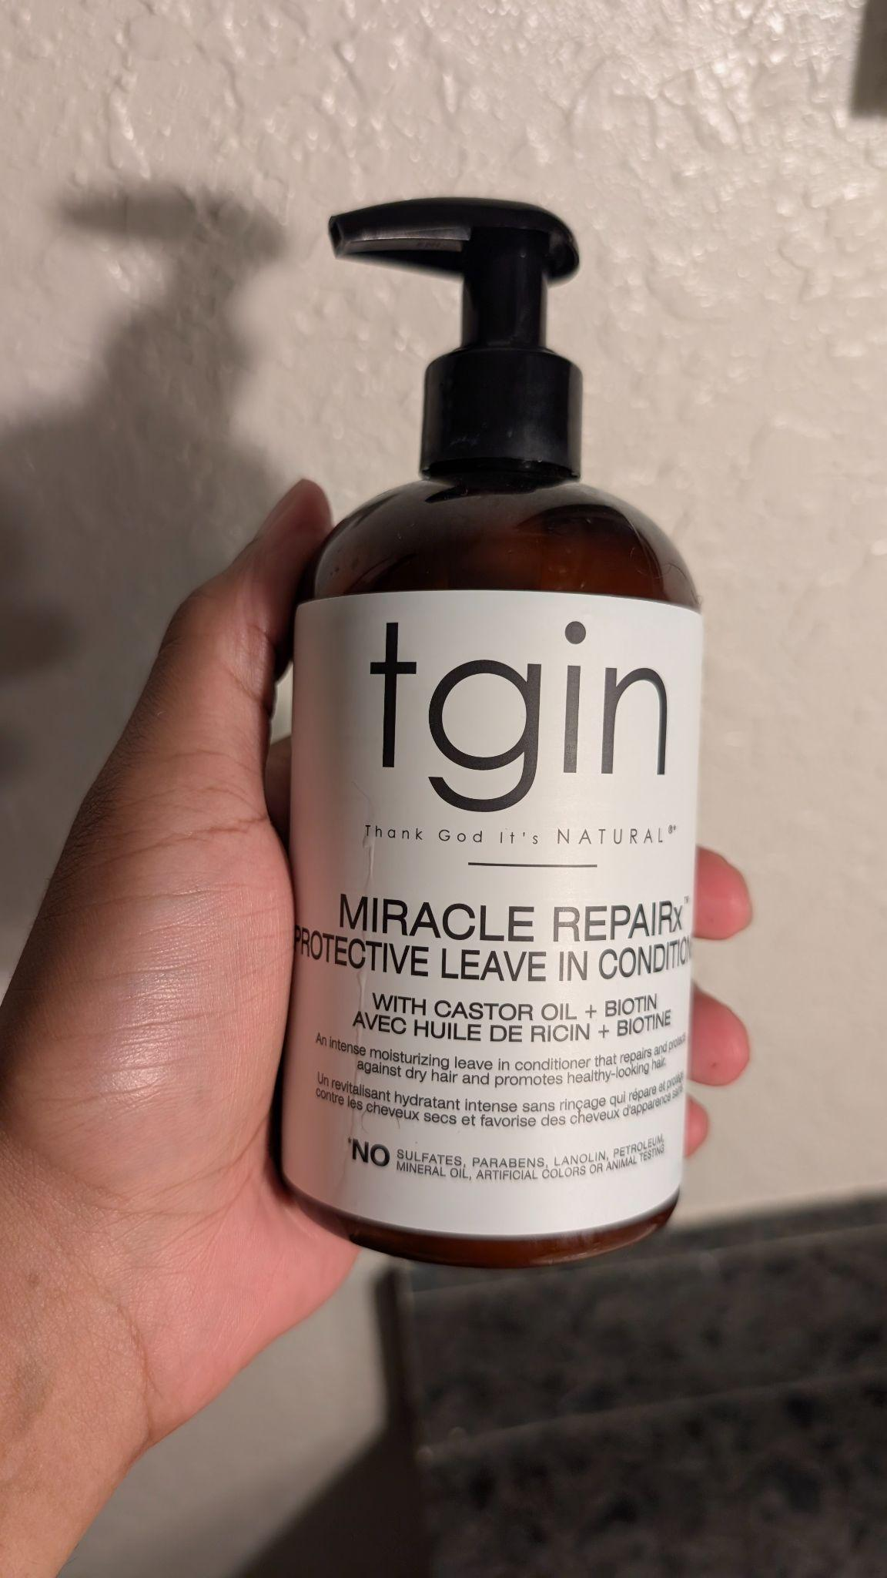

1. **Drying: Airdrying vs. Blow Drying** - Down to preferences and experiences.

For **looser curls** and **textures:**

* It is recommended to lie on your bed with your hair hanging downward until it dries (to avoid using a hair dryer).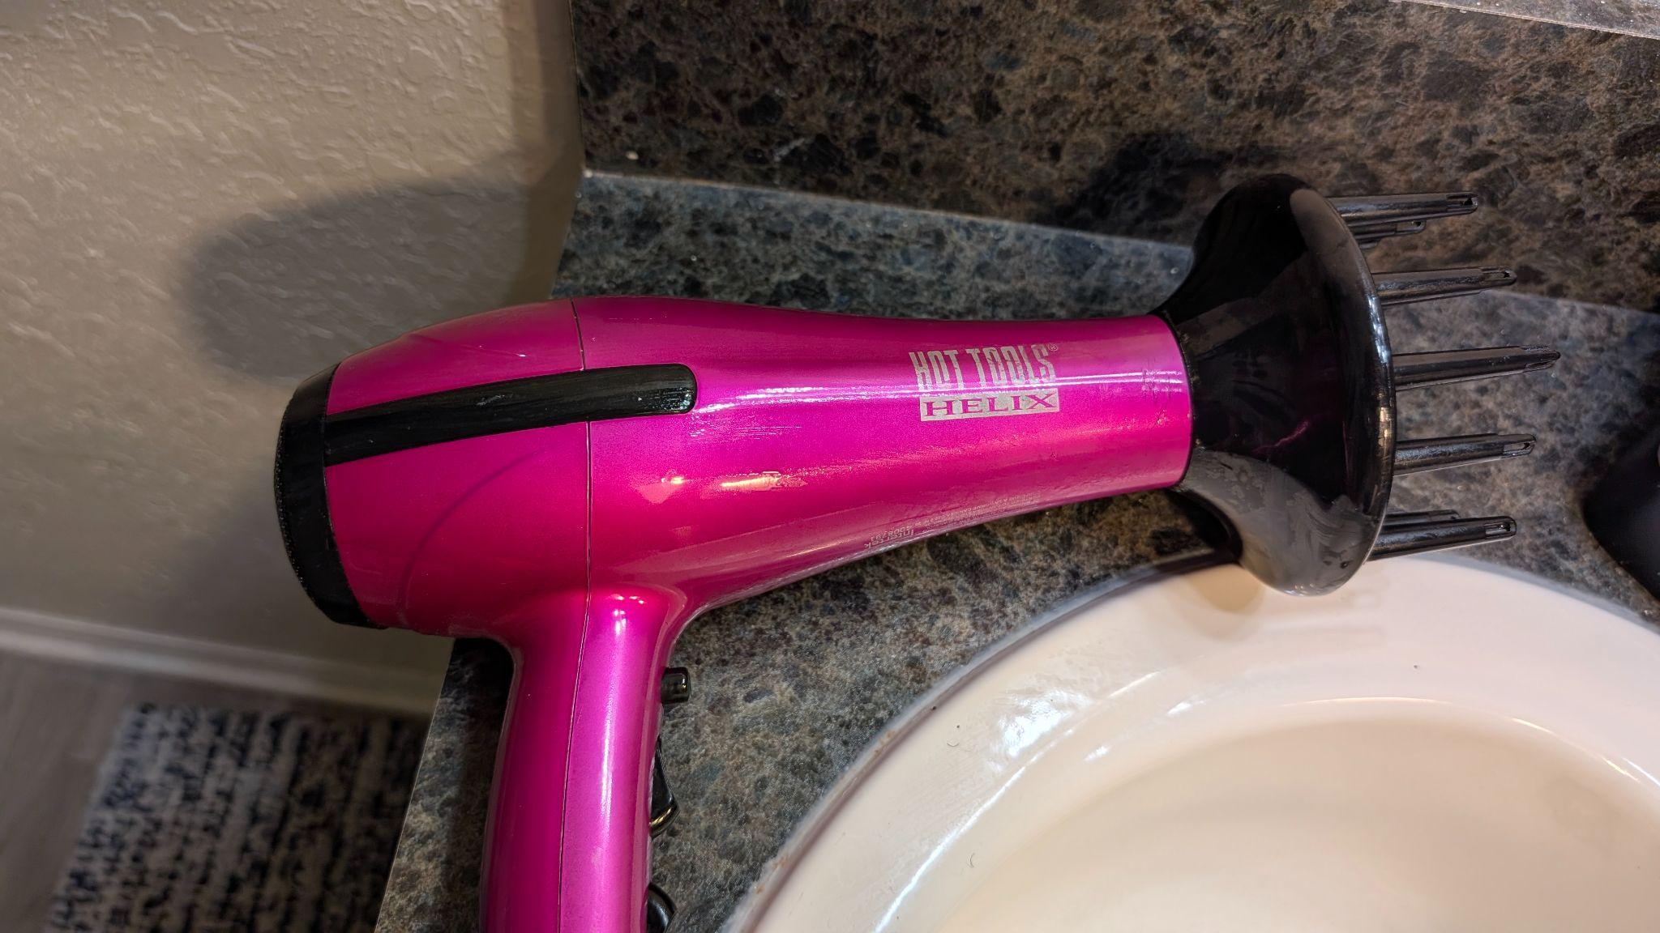
* Use a diffuser on the blow dryer. (The black, spiky thing on the end of the blow dryer image above.

Using a diffuser on an air dryer can increase how voluminous your hair looks, but try not to use too high of a heat setting to avoid heat damage.

**Applying Oils or Creams**

A critical step in the entire process and determining your wash’s outcome.

Oils are meant to:

* Lock the moisture into the hair,
* Give shine to hair,
* Promote hair growth.

If you are:

* Going somewhere and the temperature is going to be warmer than usual,
* Have already put a cream (certain ones) in your hair,
* Don’t necessarily want an oily scalp (looser textures),

Then do NOT use an oil.

If you want to:

* Have visibly shiny hair that looks moisturized,
* Will not be in an environment where you will sweat alot,
* Have trouble with sealing in and retaining moisture,

Then you SHOULD use oil in your hair. Different oils can be used, such as tea tree oil, castor oil, or coconut oil, just to name a few that can be used in conjunction with other products.

**Conclusion:**

And we’re done! Hopefully, by the end of these detailed instructions, you’re able to:

* Take caution of what could go wrong,
* Learn how to properly detangle your hair,
* Wash, condition, dry, and style your hair.

As a final tip, if you’re curls are a little stuck together after using some products, you can give them a medium-forced shake up and down, side to side, left and right, then finally up and down again to maintain a fro-like appearance!